**A Project Report**

**on**

**“IT Solution Hub”**



**Submitted By:**

**Rupesh N. Patel(06-0222-2016)**

**Major Guide: Minor Guide:**

Dr. R. S. Parmar Er. V. I. Mehra

Sign : _________________ Sign:__________________

**Certificate**



This report on **“IT Solution Hub”** is a certified

Record

of the project work submitted By

**Rupesh N. Patel**

**(Reg No : 06-0222-2016)**

in their seventh Semester of

**Bachelor of Technology**

In

Agricultural Information Technology, AAU, Anand

During the academic year 2019-2020

**Major Guide: Minor Guide:**

Dr. R. S. Parmar Er. V. I. Mehra

Sign : _________________ Sign:__________________

**Acknowledgement**

Apart from the efforts of me, the success of any project depends largely on the encouragement and guidelines of many others. I take this opportunity to express my gratitude to the people who have been instrumental in the successful completion of this project.

I would like to show my greatest appreciation to **Dr. R.S.Parmar**. I can’t say thank you enough for his tremendous support and help. I feel motivated and encouraged every time I attend his meeting. Without his encouragement and guidance this project would not have materialized.

Thank you to **Dr. Y. R. Ghodasara** (Principal and Dean, College of agricultural information technology, AAU, Anand) for providing this platform which helped in the development of my technical skills.

The guidance and support received from all the members who contributed and who are contributing to this project, was vital for the success of the project. I am grateful for their constant support and help.

**INDEX**

Contents

1. Introduction : 5

1.1 Objectives : 6

1.2 Scope : 6

2. System Requirements : 6

2.2.Software Configuration : 6

2.2.Hardware Configuration(Current): 6

2.3.Hardware Configuration(Required Minimum): 6

3. Literature Review 7

3.1. Django : 7

3.2. Working of Django : 7

3.3 The Django Framework : 7

3.4. Advantages of Django Framework : 8

3.5. Dis-advantages of Django Framework : 8

3.6. Programming language 9

3.7. Server and Client Technology 9

3.8. Development Environment 9

3.9. Description of tools used 9

3.10. Features of Visual Studio Code 9

3.11. Desining Documentation 11

3.12 JavaScript Documentation 11

4. Module List: 12

4.1. Admin Module 12

4.2. User Module 12

5. Testing: 12

5.1 Unit Testing 12

5.2. Integration Testing 13

5.3. System Testing 14

5.4. System Integration Testing 14

6. Data Dictionary: 15

6.1. User Table 15

6.2. Institute Table 15

6.3. Weather Table 15

7. System Diagrams 16

7.1. Context Diagram or Level-0 Diagram 16

7.2. Entity Relationship Diagram 17

7.3. Level-1 Diagram 17

7.4 Use case Diagram 19

7.5 Class Diagram 21

7.6 Activity Diagram 22

8. System Screenshots 25

8.1. General Screenshots 25

9. Gantt Chart: 36

10. Conclusion: 37

# 1. Introduction :

Markov chain model of the Rainfall Probability system provides an easy interface between a user and the Marko chain model. This model used for the yield of crop particularly under rain fed conditions depends on the rainfall pattern. Simple criteria related to sequential phenomena like dry and wet spells could be used for analyzing rainfall data to obtain specific information recognized as a suitable model to explain the long term frequency behavior of wet or dry spells. Several authors have demonstrated its practical utility in agricultural planning for both long and short term periods. This model enables us to determine the probability of occurrence of dry and wet spells during a particular week and also finding the Descriptive Analysis.

## Objectives :

* To create DBMS for Rainfall data of Agro meteorological observatory of Anand.
* To develop tool for Markov Model for wet and dry analysis, Descriptive data analysis and Rainfall data Normal.
* To harness Information Technology to achieve the above objectives.

## Scope :

Web Based Markov Model for wet and dry analysis, tools is the web based system using which Scientist can generate graphs and reports based on the weather data by the observatory for various purpose of their research or Agricultural Planning.

# 2. System Requirements :

## 2.2.Software Configuration :

* Tools or Text Editor : Vs code or Jupyter notebook, SQLite studio
* Browser : Any Latest Updated Browser
* Language: Python
* Database: Sqlit3

## 2.2.Hardware Configuration(Current):

* Processor : Intel core I3
* RAM : 8 GB
* Hard Disk : 1 TB

## 2.3.Hardware Configuration(Required Minimum):

* Processors: Intel Atom® processor or Intel® Core™ i3 or higher
* RAM: 1 GB
* Hard Disk : As per User Requirement.

# 3. Literature Review

## 3.1. Django :

* **Django** was created in the fall of 2003, when the web programmers at the Lawrence Journal-World newspaper, Adrian Holovaty and Simon Willison, began using Python to build applications. It was released publicly under a BSD license in July 2005. The framework was named after guitarist **Django** Reinhardt.

## 3.2. Working of Django :

* Django can look complicated at first. Just navigating to a single, simple page can involve code in three or four different files. Django utilizes a design paradigm widely known as "MVC architecture", or rather, a slight

variation they tend to refer to as "MTV". In this the code is split between a Model, a View, and a Controller. Or, in Django's version, a Model, Template, and View. While this isn't going to attempt to be a thorough explanation of this system ([The Django Book's first chapter](http://www.djangobook.com/en/2.0/chapter01/) already does a much better job of that than I could ever attempt) it will attempt to walk through a section of our code and explain how it works and how to trace your way through the process that renders a webpage when you navigate to a URL.

## 3.3 The Django Framework :

* Django is a high-level Python Web framework that encourages rapid development and clean, pragmatic design. Built by experienced developers, it takes care of much of the hassle of Web development, so you can focus on writing your app without needing to reinvent the wheel. It’s free and open source.

## 3.4. Advantages of Django Framework :

* + **Fast :**This has been designed in a way to help the developers make an application as fast as possible. From idea, production to release, Django helps in making it both cost effective and efficient. Thus it becomes an ideal solution for developers having a primary focus on deadlines.
  + **Fully Loaded :**It works in a way that includes dozens of extras to help with user authentication, site maps, content administration, RSS feeds and much more such things. These aspects help in carrying out the web development process completely.
  + **Secure :** When you are doing it in Django, it is ensured that developers don’t commit any mistakes related to security. Some of the common mistakes include SQL injection, cross-site request forgery, clickjacking and cross-site scripting. To manage effectively usernames and passwords, the user authentication system is the key.
  + **Scalable :** To meet the heaviest traffic demand, the benefits of Django framework can be seen. Therefore, the busiest sites use this medium to quickly meet the traffic demands.

## 3.5. Dis-advantages of Django Framework :

* Uses routing pattern specify its URL.
* Django is too monolithic.
* Everything is based on Django ORM.
* Components get deployed together.
* Knowledge of full system is required to work*.*

## 3.6. Programming language

* Python

## 3.7. Server and Client Technology

* Wsgi(Web Server Gateway Interface) server.
* Also run on Apache, Gunicorn, Nginx servers.

## 3.8. Development Environment

* Visual Studio Code(IDE) in my Project.
* Support any text editor.

## 3.9. Description of tools used

* Working with Python in Visual Studio Code, using the Microsoft Python extension, is simple, fun, and productive.
* The extension makes VS Code an excellent IDE, and works on any operating system with a variety of Python interpreters.
* It leverages all of VS Code's power to provide auto complete and IntelliSense, linting, debugging, and unit testing, along with the ability to easily switch between Python environments, including virtual and conda environments.

## 3.10. Features of Visual Studio Code

#### 1. Intellisense

IntelliSense is code **auto-complete meets artificial intelligence**. This utility provides a list of suggestions along with a short hint or description as we are writing codes. These is **derived from several contextual factors** such as the programming language, the syntax, the variables, the functions as well as all the codes within the file.

IntelliSense supports a number of programming language out-of-the-box, including Sass, LESS, JavaScript, TypeScript, and PHP. Some extensions to include IntelliSense for other programming languages are also available. It is a great feature to improve productivity.

#### 2. Peek

While coding, you may often forget a particular function, where the function is initially defined, and what are the required parameters.

With **Peek**, you can select a function then hit Shift + F12. The selection **expands into an inline window showing the complete definition of the function** as well as where the function is defined. The feature currently works in C, C#, JavaScript, TypeScript, .NET, and a few other programming languages.

#### 3. CLI

Similar to SublimeText with its subl command line, Visual Studio Code is equipped a CLI named code and it is easy to install.

In Windows, the CLI will have already been installed along with the app. The CLI is accessible through the Command Prompt. In OS X, it can be installed and uninstalled through the Command Palette.

You can use the CLI to open a particular directory to Visual Studio Code, or open your current project directory in Terminal or Command Prompt directly from the editor.

#### 4. Built-in Git

Visual Studio Code has Git built right in the editor. On the left of the sidebar, you will find the Git icon where you can [initialize Git](https://git-scm.com/docs/git-init) as well as **perform several Git commands** such as commit, pull, push, rebase, publish, and look into the changes within the file.

In addition, if you are making changes on a Git repository, the Visual Studio will **show color indicators in the code editor gutter**, indicating where you have made the modifications.

#### 5. Task Runner

Last but not least, Visual Studio Code also has a built-in Task Runner, which provides some level of convenience.

To use this feature, we can either set a tasks.json file or through some popular Task configuration like Grunt, Gulp, or MSBuild if provided. Once the configuration is set, we can run the Task Runner through the Command Palette by typing **Run Task**. Typing **Tasks** will list all related commands.

## 3.11. Desining Documentation

* Twitter Bootstrap is the most popular front end frameworks currently. It is sleek, intuitive, and powerful mobile first front-end framework for faster and easier web development. It uses HTML, CSS and JavaScript.
* CSS describes how HTML elements are to be displayed on screen, paper, or in other media.

## 3.12 JavaScript Documentation

* JavaScript is a programming language that lets you supercharge your HTML with animation, interactivity, and dynamic visual effects. JavaScript can make web pages more useful by supplying immediate feedback. For example, a JavaScript-powered automatic calculation can instantly display a total cost, with tax and estimated cost. JavaScript can produce an error message immediately after someone attempts to submit a web form that’s missing necessary information.

# 4. Module List:

## 4.1. Admin Module

* In This Module Admin can Upload Data and Insert, update, and Delete also.
* Admin can show the log of All Users and User Account Activation.

## 4.2. User Module

* In This Module Users can Registration after Activated by Admin.
* Users can Analysis of Markov chain Analysis and Descriptive Analysis.
* User can Change the Password of own Account.

# 5. Testing:

### 5.1 Unit Testing

#### 1. Objective

* The objective of Unit Testing is to test a unit of code (program or set of programs) using the Unit Test Specifications, after coding is completed. Unit testing tests the minimal software component, or module.
* Each unit of the software is tested to verify that the detailed design for the unit has been correctly implemented. In an object-oriented environment this is usually at the class level, and the minimal tests include the constructors and the destructors.
* Since the testing will depend on the completeness and correctness of test specifications, it is important to subject these to quality and verification reviews

#### 2. Input

* Unit Test Specifications
* Code to be tested

#### 3. Testing Process

* Checking for availability of Code Walk-through reports which have documented the existence of and conformance to coding standards.
* Review of Unit Test Specifications.
* Verify the Unit Test Specifications conform to the program specifications.
* Verify that all boundary and null data conditions are included.

**4. Following are some of the test cases that are given below:**

* Registration Form Validations Testing.
  + Text Field.
  + Number Field.
  + Email Field.
  + Password Field.
  + Regular Expression Validation for each Fields.
* Module Testing
  + Admin
  + Users

### 5.1. Test cases

### 5.2. Integration Testing

* Integration testing exposes defects in the interfaces and interaction between integrated components (modules). Progressively larger groups of tested software components corresponding to elements of architectural design are integrated and tested until the software works as a system.
* As Modular coding strategy was used, after completion of my module and integrating the module with the complete application, time was given to me to test their part of module completely and thoroughly.
* Integration testing takes as its input, modules that have been checked out by unit testing, groups them in larger aggregates, applies tests defined in an integration test plan to those aggregates, and delivers as its output the integrated system ready for system testing.

**Following are some of the test cases that are given below:**

1. Verify that communication between the systems are done correctly

2. Understand how the data is transferred from one module to another.

3. Is record fetch automatically from one module to another?

### 5.3. System Testing

* System Testing (ST) is a black box testing technique performed to evaluate the complete system the system's compliance against specified requirements. In System testing, the functionalities of the system are tested from an end-to-end perspective.
* System Testing is usually carried out by a team that is independent of the development team in order to measure the quality of the system unbiased. It includes both functional and Non-Functional testing.

### 5.4. System Integration Testing

* System [Integration Testing](https://www.guru99.com/integration-testing.html) is defined as a type of software testing carried out in an integrated hardware and software environment to verify the behavior of the complete system. It is testing conducted on a complete, integrated system to evaluate the system's compliance with its specified requirement.
* System Integration Testing (SIT) is performed to verify the interactions between the modules of a software system. It deals with the verification of the high and low-level software requirements specified in the Software Requirements Specification/Data and the Software Design Document.
* It also verifies a software system's coexistence with others and tests the interface between modules of the software application. In this type of testing, modules are first tested individually and then combined to make a system.
* For Example, software and/or hardware components are combined and tested progressively until the entire system has been integrated

# 6. Data Dictionary:

## 6.1. User Table

|  |  |  |  |  |  |
| --- | --- | --- | --- | --- | --- |
| Data Element | Alias | Data Type | Null able | Constrain | Description |
| User id | U_id | Int | Not Null | PK | The unique identification key for User |
| First Name | F_name | Varchar(50) | NotNull | - | The field for first name |
| Last Name | L_name | Varchar(50) | NotNull | - | The field for last name |
| Supper User | Is_supper | Bool | Notnull,default:0 | - | The field for Admin user |
| Email | Email | Varchar(50) | NotNull | - | The field for user Email id |
| Activite | Is_active | Bool | NotNull default:0 | - | This field for user Activation |
| Password | Pass | Varchar(20) | NotNull | - | This field for Password |
| Institute id | I_id | Int | Notnull | FK | This is Institute identification key |

## 6.2. Institute Table

|  |  |  |  |  |  |
| --- | --- | --- | --- | --- | --- |
| Data Element | Alias | Data Type | Null able | Constrain | Description |
| Instituted id | I_id | Int | Not Null | PK | The unique identification key for Instituted |
| Instituted name | Name | Varchar(20) | Not null | - | This field for instituted Name |

## 6.3. Weather Table

|  |  |  |  |  |  |
| --- | --- | --- | --- | --- | --- |
| Data Element | Alias | Data Type | Null able | Constrain | Description |
| Data id | D_id | Int | Not Null | PK | The unique identification key for Weather Data |
| Date | Date | Date&time | Not null | - | This field use for Daily data |
| EP | Ep | Float(5,2) | Not null | - | This field use for Evaporation |
| ET | Et | Float(5,2) | Not null | - | This field use for Evapo-Transpiration |
| Bss | Bss | Float(5,2) | Not null | - | This field use for Sunshine hour |
| Ws | Ws | Float(5,2) | Not null | - | This field use for Wind speed |
| Wd | Wd | Float(5,2) | Not null | - | This field use for Wind direction |
| RF | Rf | Float(5,2) | Not null | - | This field use for Rain fall |
| RH | Rh | Float(5,2) | Not null | - | This field use for Relative Humidity |
| MaxTEMP | Maxt | Float(5,2) | Not null | - | This field use for Maximum temperature |
| MINT | Mint | Float(5,2) | Not null | - | This field use for Mean temperature |

# 7. System Diagrams

## 7.1. Context Diagram or Level-0 Diagram

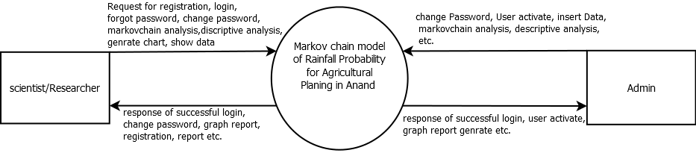

## 7.2. Entity Relationship Diagram

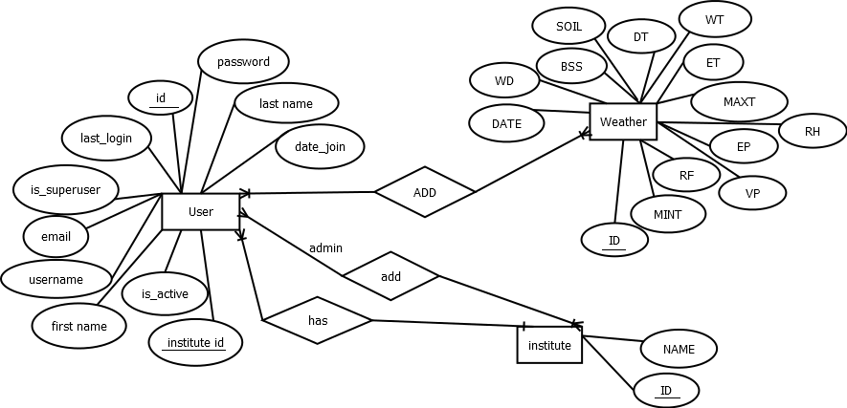

## 7.3. Level-1 Diagram

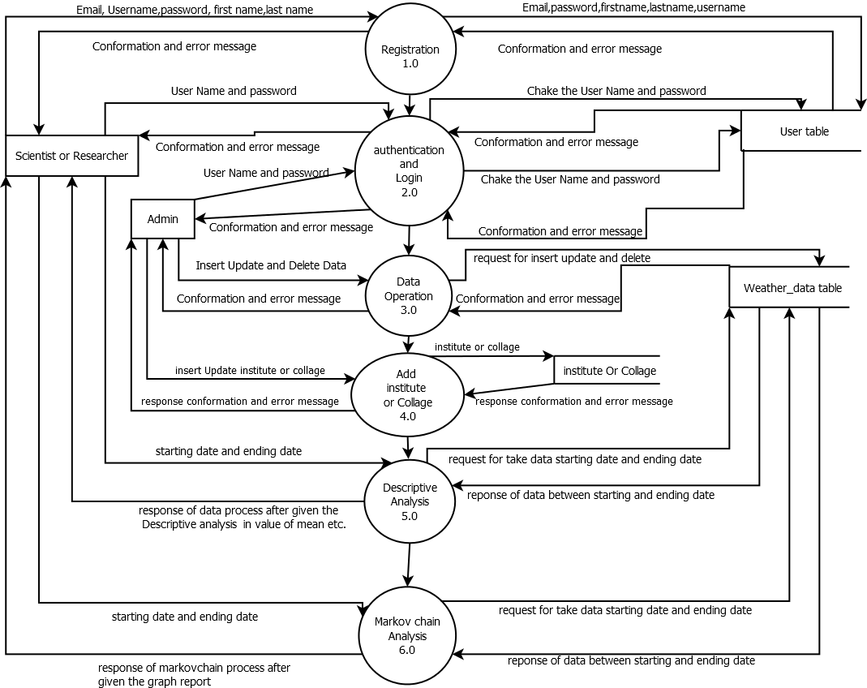

## 7.4 Use case Diagram

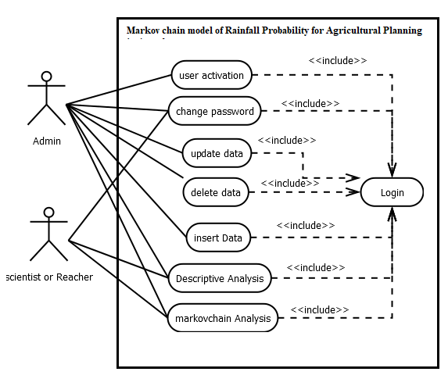

Admin Module

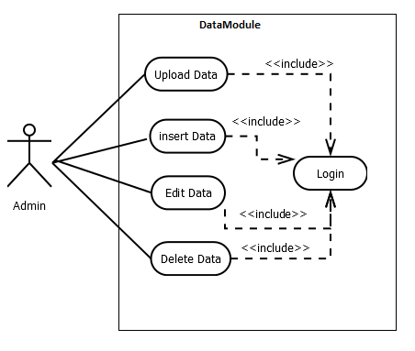

Admin

Users

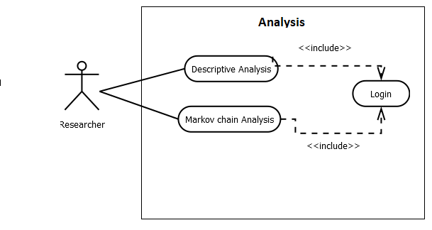

User

## 7.5 Class Diagram

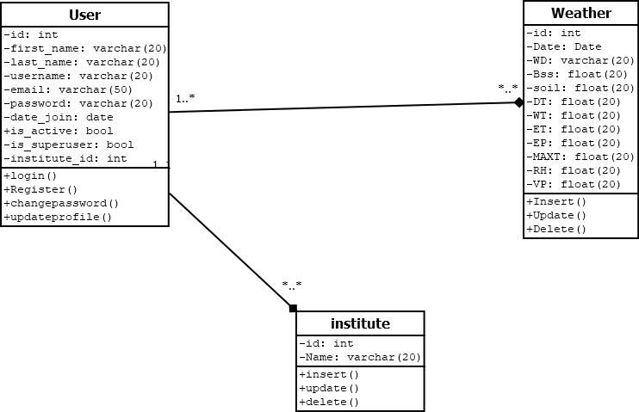

## 7.6 Activity Diagram

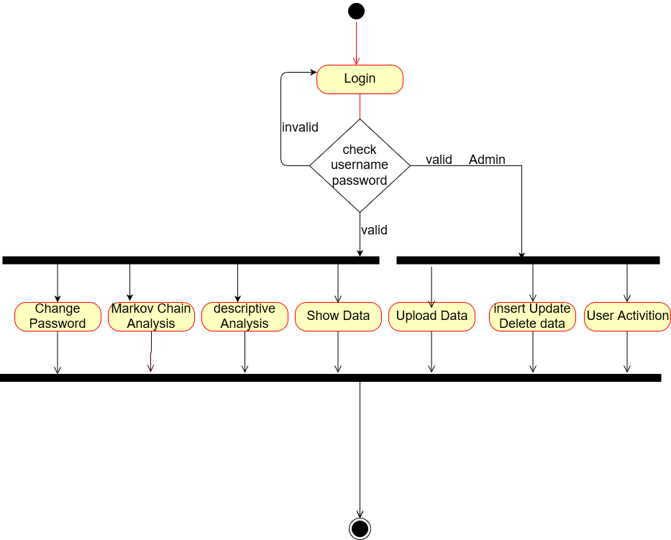

**Admin Module**

# Admin Activity.png

Users Module

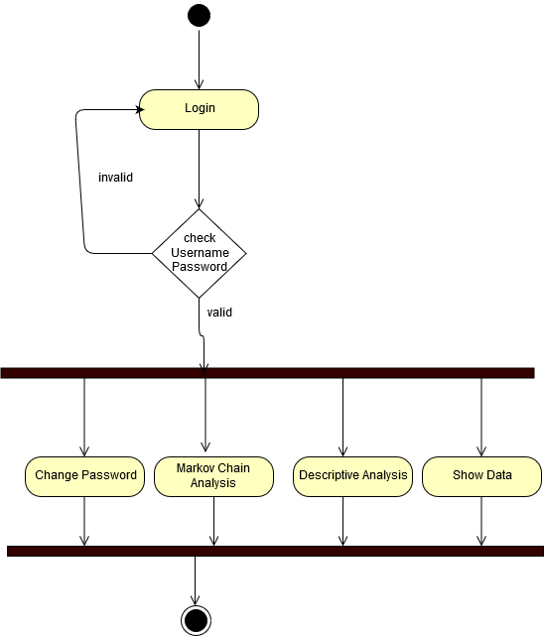

# 8. System Screenshots

## 8.1. General Screenshots

1.Home Page

* This is image of Home Page

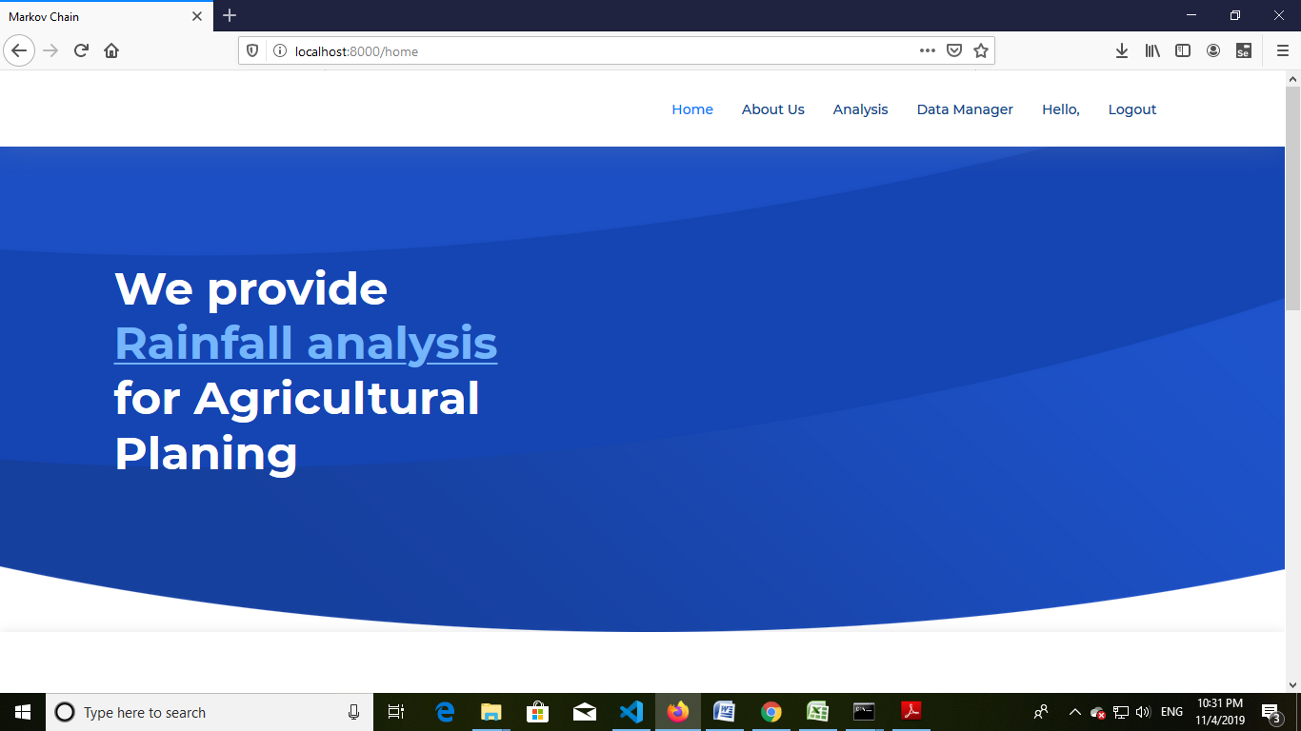

2.Weather Data

* This is image of all Weather data show in Admin Login.

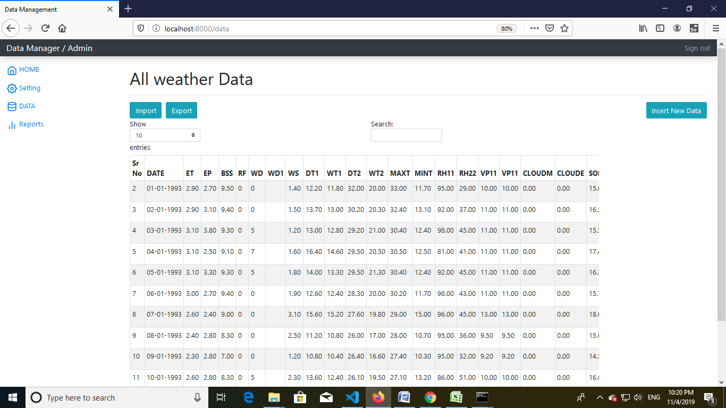

3.Login Page

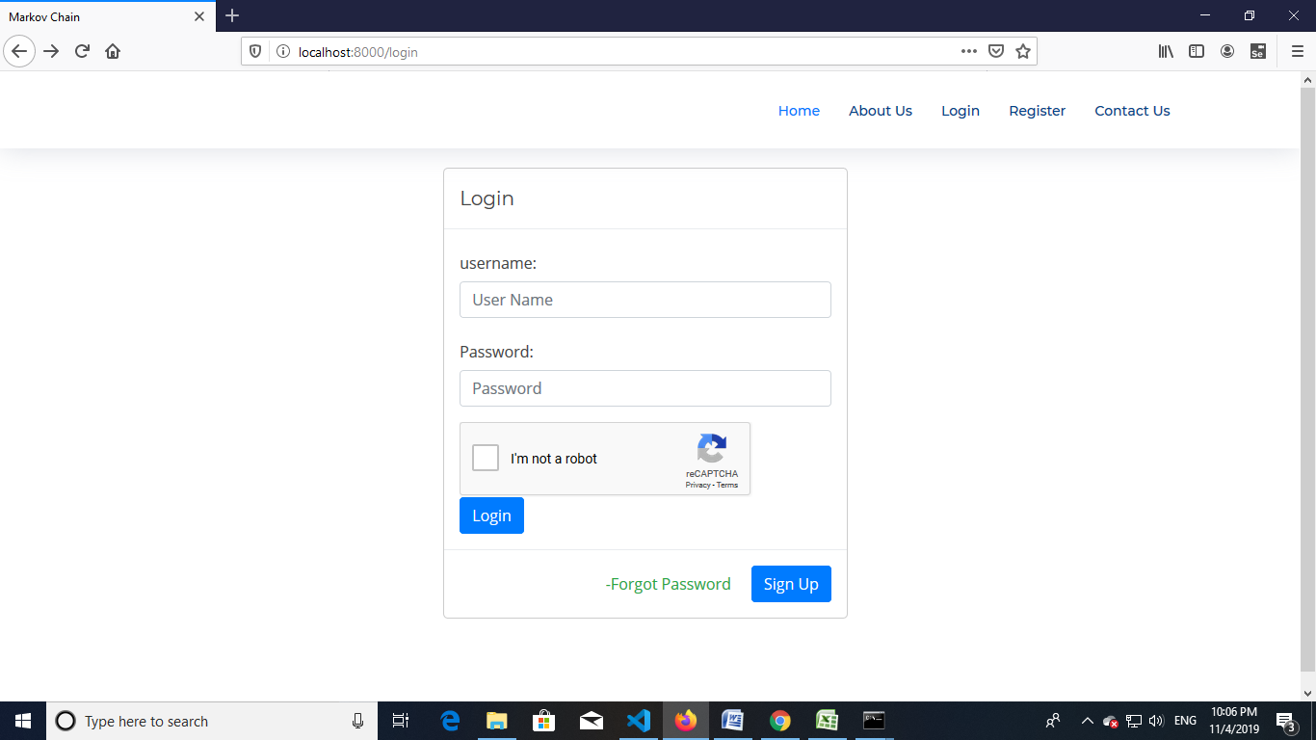

* This image of login page.

4.Registration Page

* This image of Registration page.

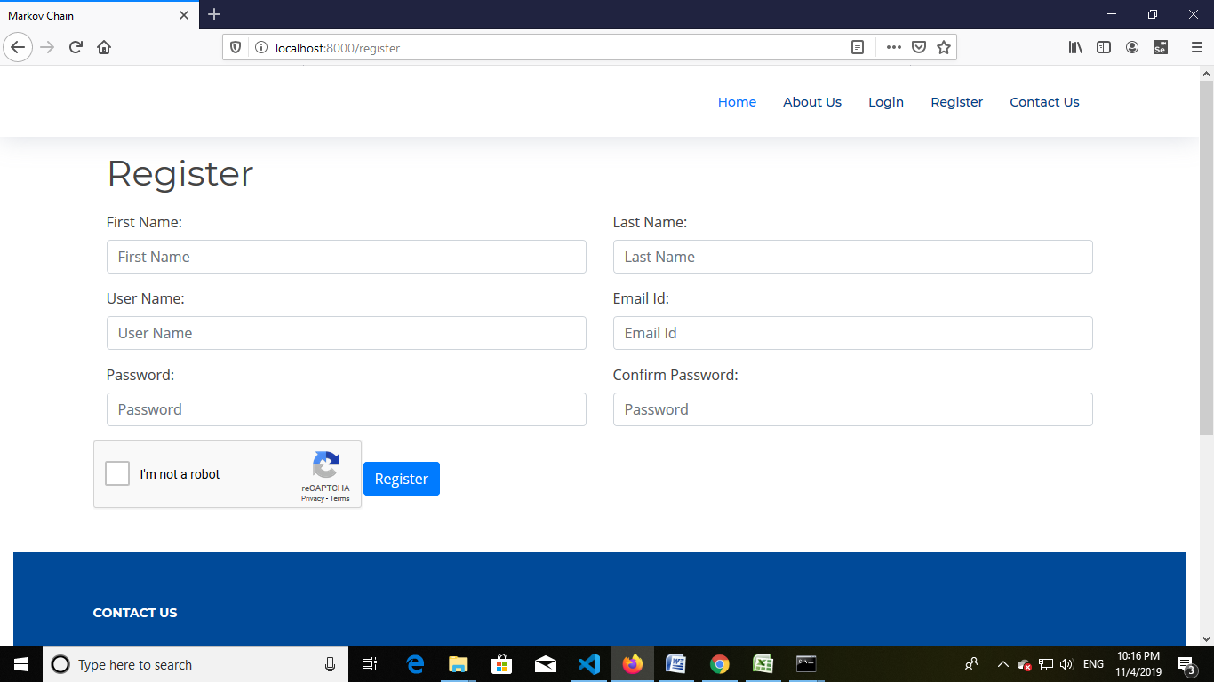

6.Chepcha verification

* This image of re-CAPTCHA verification

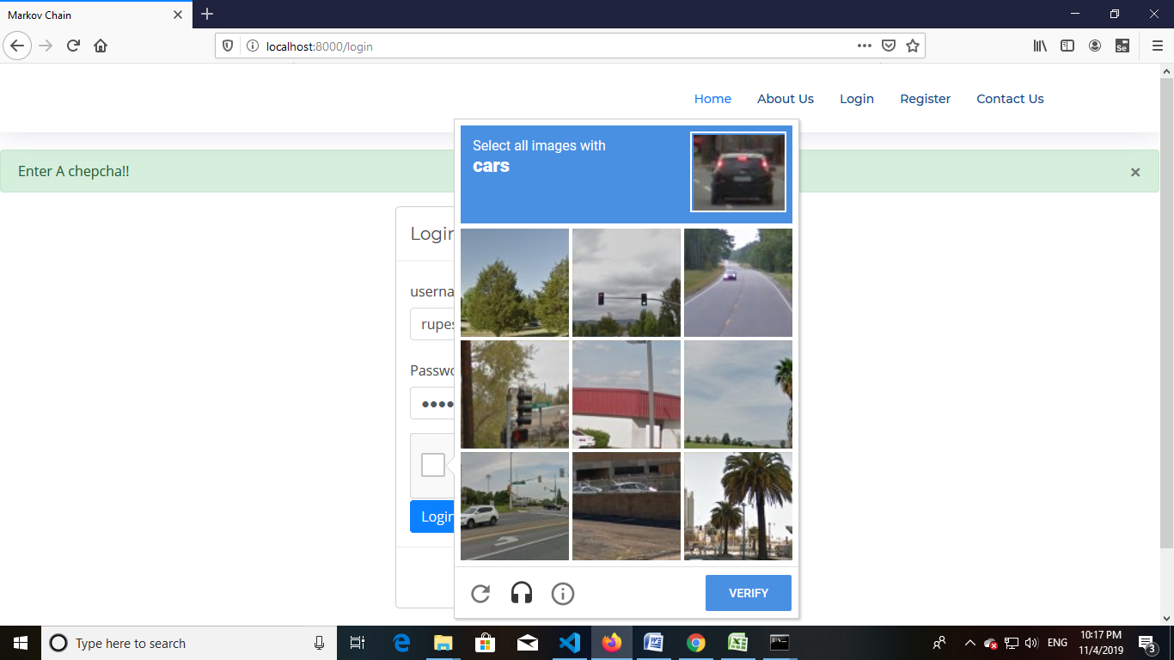

7. Filter Data

* This image of filter data page.

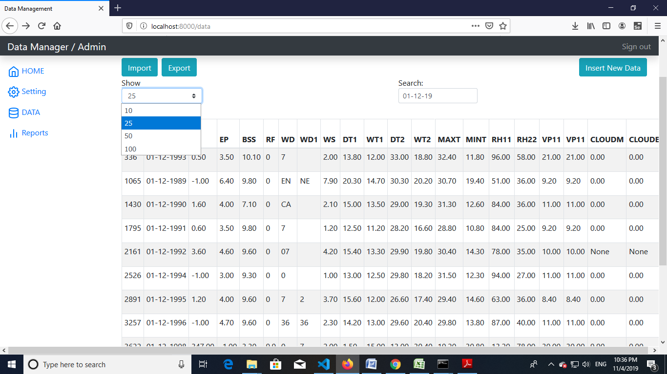

8. Import Data

* This image of import data in Weather dateable.
* This page through insert the csv file.

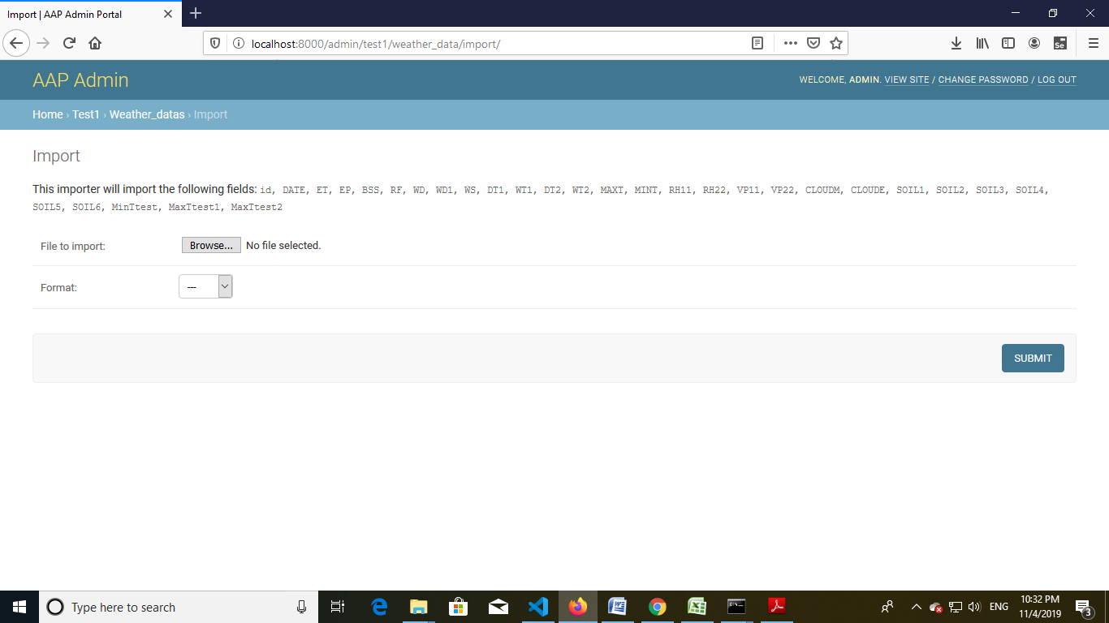

9. Export Data

* This image of Export Data in csv file and other file formate.

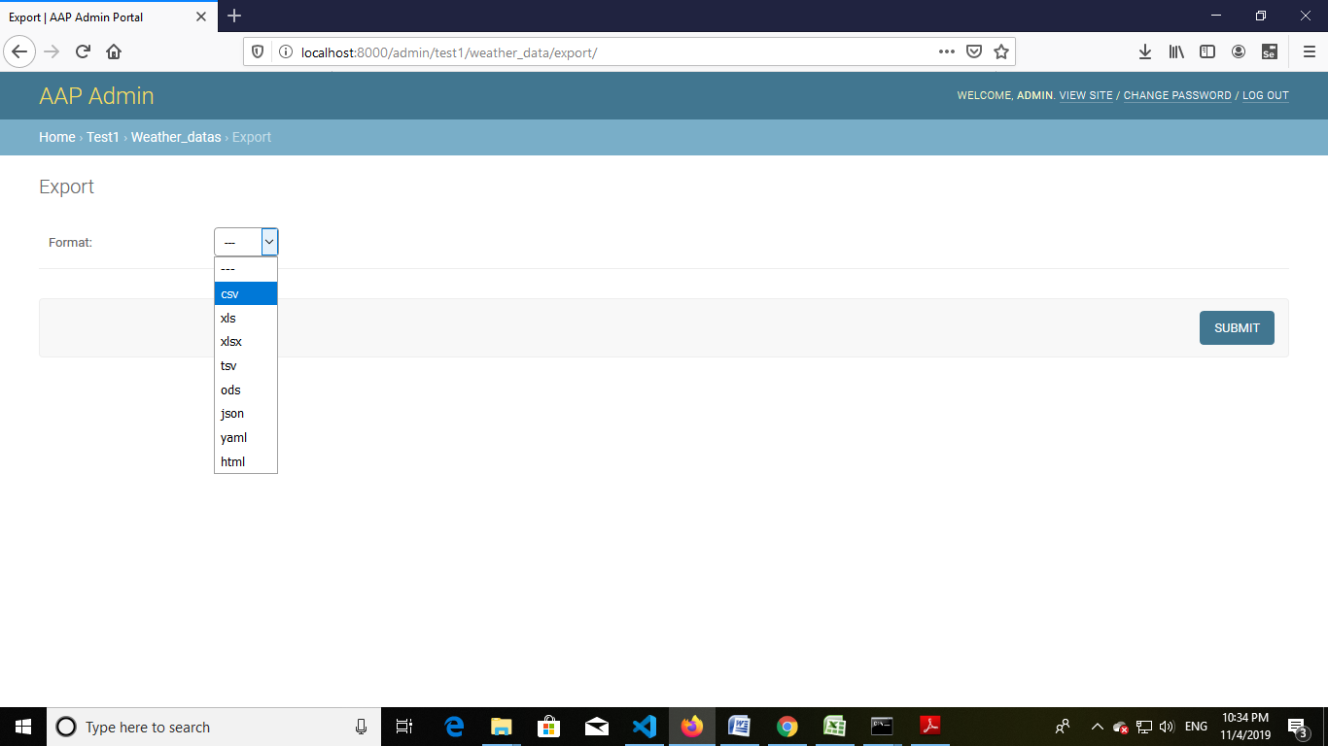

10.Analysis Module

A. Descriptive Analysis

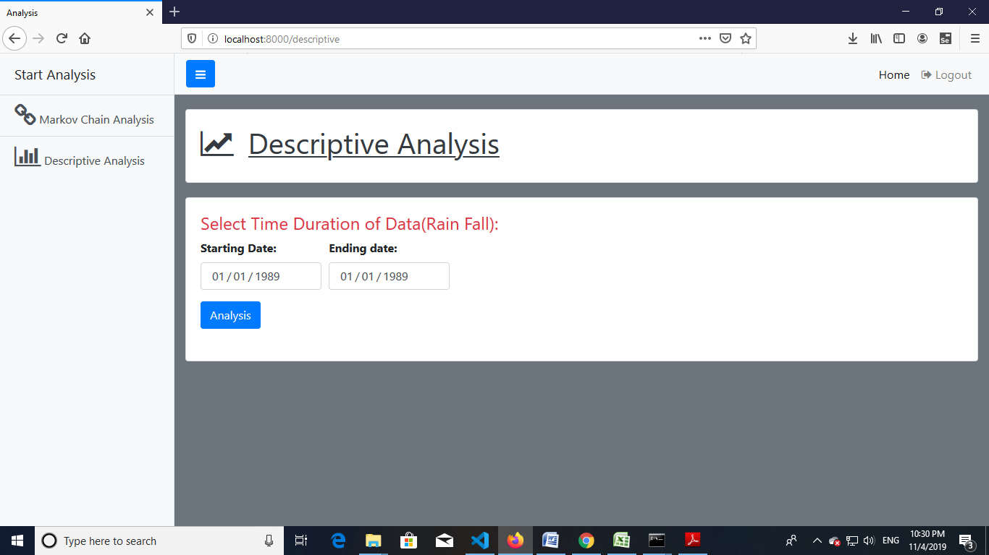

* This image in selected date and after click the Analysis button .

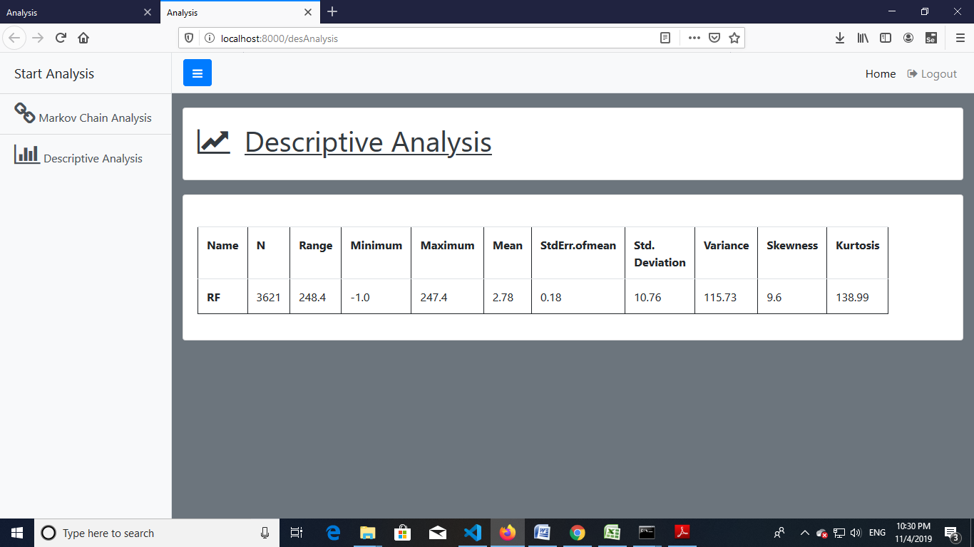

* This is image of Descriptive Analysis of Answer.

B. Markov chain Analysis

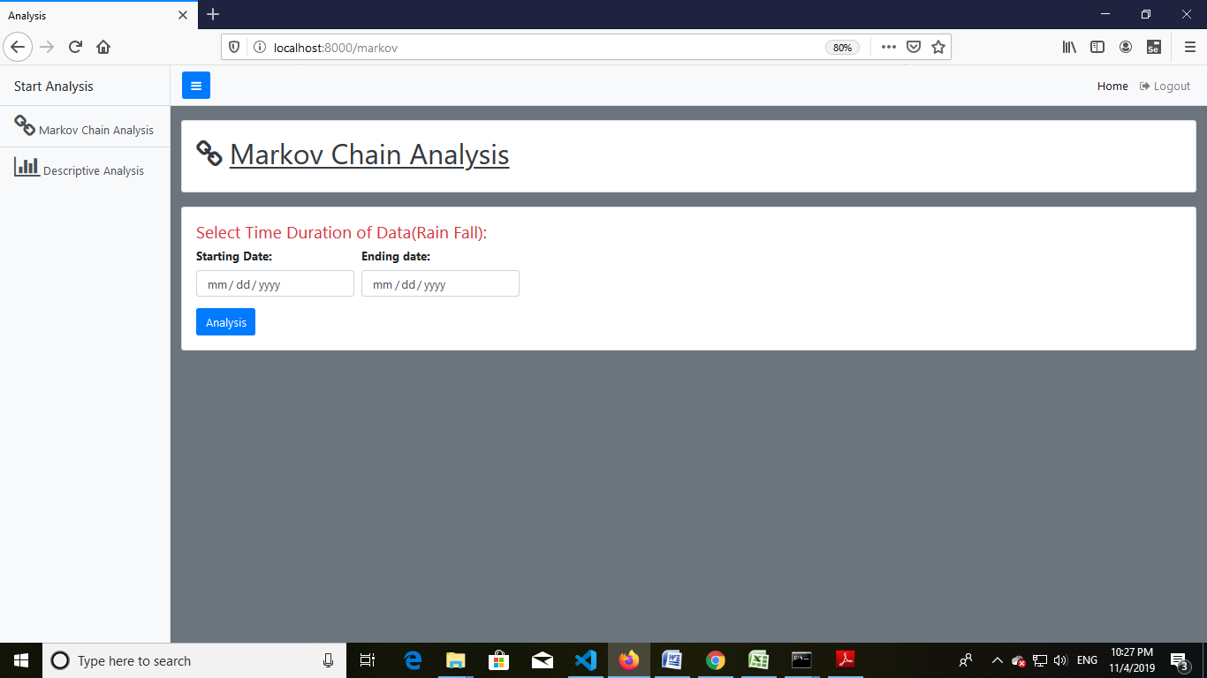

* This Page in select the date and after click the Analysis button.

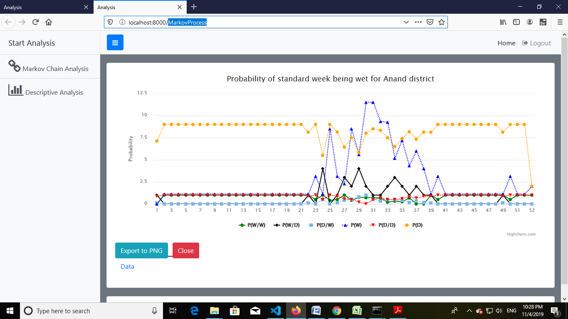

* This page in Analysis of graph of Markov chain Analysis.

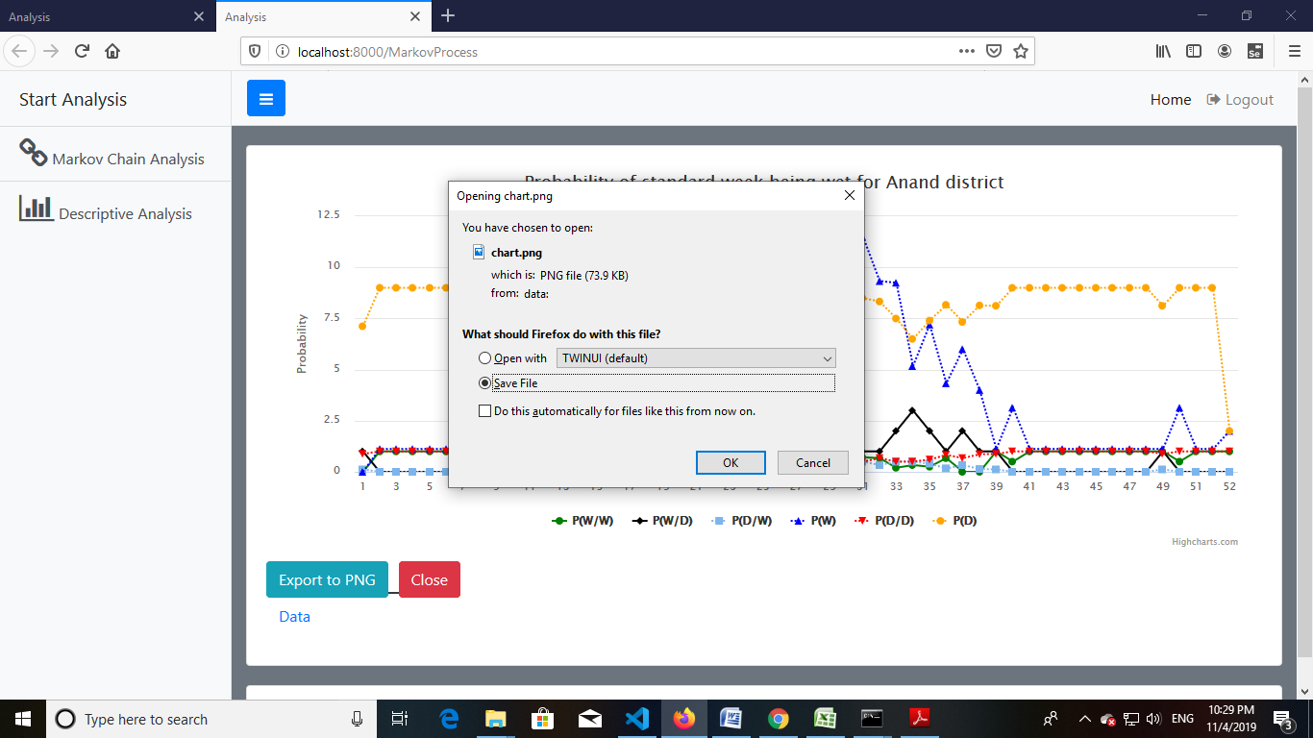

* This image of export graph of image.

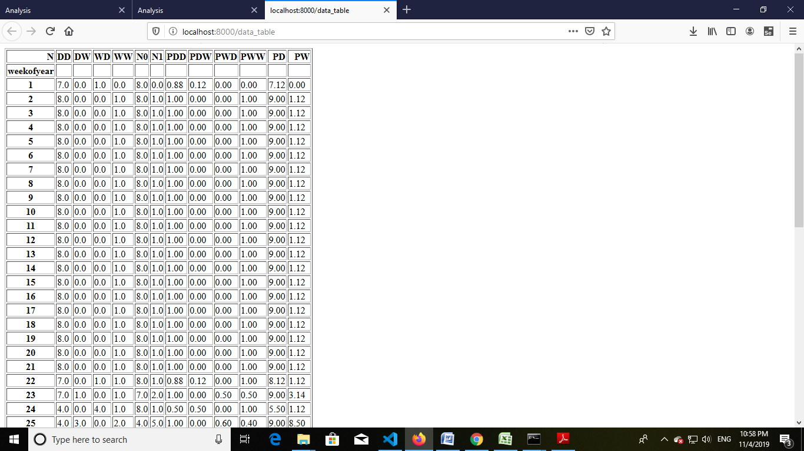

* This image in Data of Markov chain Analysis of Graph Data.

9. Report

A. Daily Report

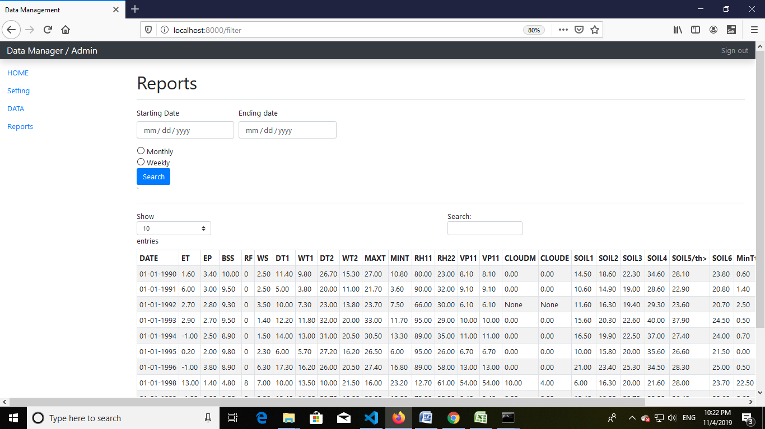

B. Monthly Data

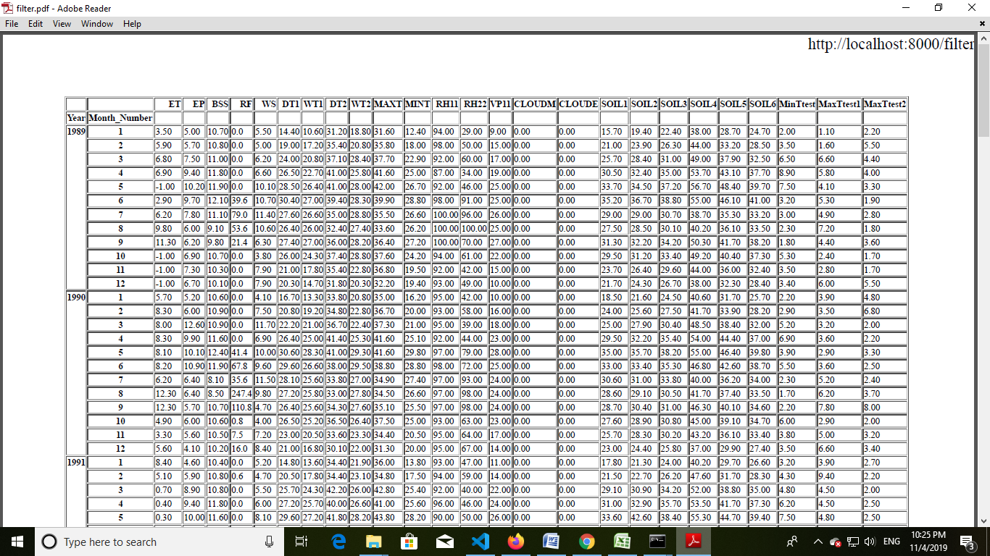

C. Weekly

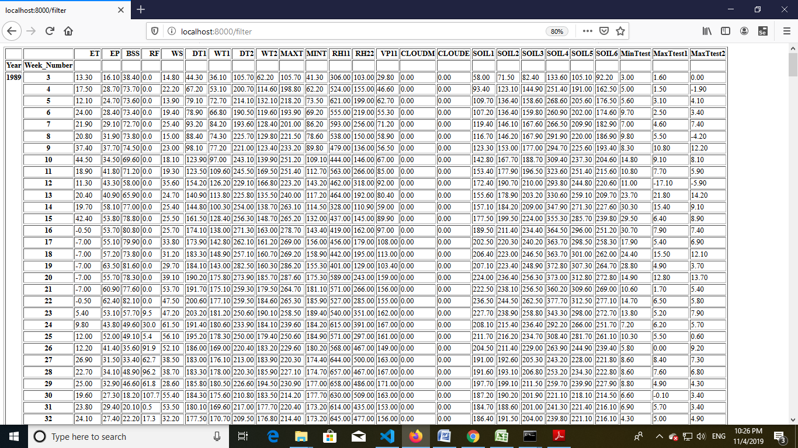

* This image in Report of weekly data.

# 9. Gantt Chart:

* **Process**
* Requirement Gathering(15 days)
* System Analysis(10 days)
* System Design(15 days)
* Registration(3 days)
* Login(2 days)
* Data Up loader(6 days)
* Weather Data module(15 days)
* Markov chain module(20 days)
* Descriptive Analysis(15 days)
* Change Password(1 days)
* User Activation(5)
* Generate Report(10 days)

# 10. Conclusion:

11. References:

* CALIFORNIA INSTITUTE OF TECHNOLOGY, Ma 3/103 KC Border Introduction to Probability and Statistics Lecture 13: Markov Chains and Martinagles
* Introduction to Markov Chains To word Data science [https://towardsdatascience.com/introduction-to-markov-chains-50da3645a50d]
* International Journal of Innovative Research in Science, Engineering and Technology (An ISO 3297: 2007 Certified Organization) Vol. 4, Issue 7, July 2015 Copyright to IJIRSET DOI:10.15680/IJIRSET.2015.0407199 6644 Markov Chain Model for Probability of Weekly Rainfall in Mandya District, Karnataka
* [http://www.ijirset.com/upload/2015/july/199_krishnamurthy%20int%20jul.pdf]